Jurskis, Victor Paul (from www.slic.org.au)
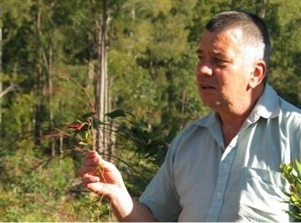

Has B.Sc. (Forestry) Australian National University.
Is a Silviculturist with the Native Forests Division of Forests New South Wales. He lives now at Eden on the southeast coast of NSW. Has written about 20 papers, some in cooperation with other colleagues, which are published in journals and other formats, many in "Australian Forestry". He has addressed conferences such as the "3rd International Wildland Fire Conference" and the "Joint Australia and New Zealand Institute of Forestry Conference" in 2003. His main field of interest is in forest health and fire management in Australian forests. He has been involved in research of forest regeneration and growth, forest decline, prescribed burning for biodiversity and protection of society, koalas, smoky mice and mistletoes.

Started working as a fieldworker in pine plantations around Lithgow. A couple of years later, appointed as a junior forester at Casino with the Forestry Commisssion. From 1979 to 1985 worked as a forester at various locations on the far north coast, managing coastal native forests (rainforest and eucalypt). From 1985 to 1987 was District Forester at Cobar, assessing and managing native timber resources (cypress pine), mostly on leasehold land in the Western Division. From 1987 to 1996 was Research Forester at Eden, where I was involved in all sorts of ecological research about regeneration and growth of eucalypt forests, fire, forest health, koalas and smoky mice. Between 1996 and 2002 was Planning Manager for the Eden Region, doing strategic planning for native forest management. Since 2002 has worked as Silviculturist in native forests throughout NSW, but continue to work from Eden. Provides advice, direction, education and monitoring relevant to silviculture policy and practice, and have a particular interest in forest health management and fire ecology. In 2004 was awarded a Fellowship by the Gottstein Trust to examine forest health issues in Western Australia, Tasmania and Victoria.

